Virtual Career Fair
Student Instructions
- You do not need to RSVP to attend a virtual career fair
- Log into your CSM student account
- Navigate to the virtual career fair via Events > Career fairs on your left-hand menu
- Click into the virtual career fair by clicking on the title of the fair
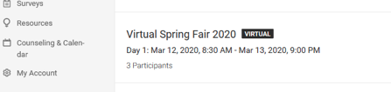

- Click the “See Who’s Coming” button or scroll down to the list of employer participants
The employers who have logged in and are ready to chat will display a “Live Chat” button that you may click to initiate a chat conversation. You may chat with one or multiple employers at a time.
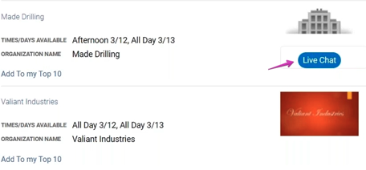

- Click “Live Chat” and a popup box chat box will display where you may type a question or statement to the employer and select “Chat” to send a chat request and await a response. Note that employers are chatting with multiple students and it could take them a bit to respond; be patient.
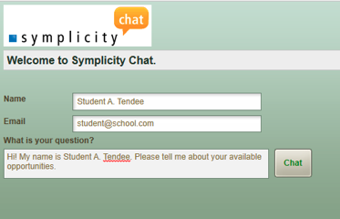

- Once the employer accepts your chat invitation, you will see the window below and shortly thereafter, you will see their response to you and your chat has begun!
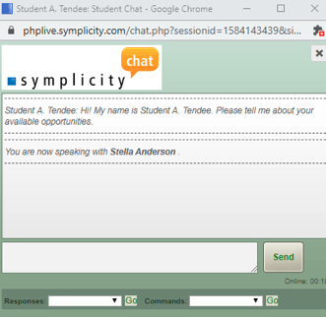

Student FAQs

Q: Can students access a Virtual Career Fair and chat with employers/registrants from the app?
A: Virtual Chat is available within the Symplicity Jobs and Careers App. Students may chat with employers via the app. Students may chat with multiple employers via the app, but it will be harder to manage from their phone. Each chat session will open as a new window in their phone's browser. The ideal setup for students to chat with multiple employers/registrants at once is via a computer.

Q: I cannot hear any sound even though the sound is turned on in the chat window.
A: In order to hear sounds from the Live Chat feature, you must enable Flash in your browser.
Q: Can students send a resume to employers via the chat feature?
A: There is not an option to upload a document via the chat feature; however, students can provide a link to their Public Profile which will include their default resume. To obtain this link, students will sign into their CSM account > My Public Profile > make sure Publish is toggled to On > click the Share It link > copy the public URL to their Public Profile.

Q: Can students chat with multiple employer/registrants at one time?
A: Students may chat with multiple employers at one time. Each chat will be in a separate window.
Q: Do students have to RSVP to an event in order to chat with registrants?
A: Students do NOT have to RSVP to a fair in order to participate in Virtual Career Fair Chat.

