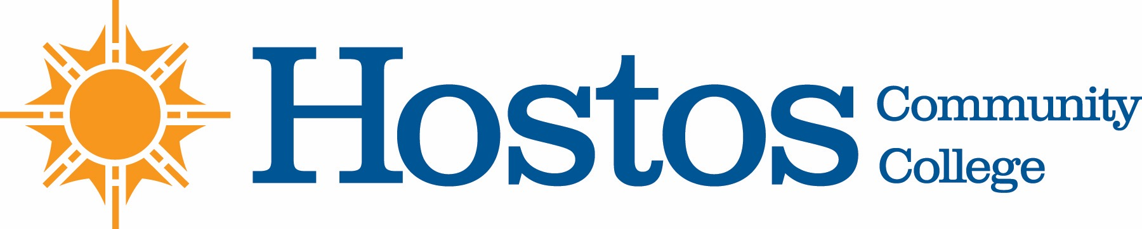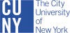

COLLEGE-WIDE CURRICULUM COMMITTEE
AGENDA
Tuesday, May 4, 2021

- Acceptance of Agenda

- Minutes of Tuesday, April 20, 2021

- Fall 2021 CWCC Calendar (Pre & Post Revisions)

- Curriculum Items:

Behavioral & Social Sciences

Course change ECO 101
ECO 102

Course change PPA 111

New course HIS 212

Natural Sciences

Course change BIO 140
BIO 141

- Informational

Proposal to Establish an “A.A. Degree in Liberal Arts & Science Unit” within the Office of Academic Affairs for the administration of the A.A. Degree in Liberal Arts & Science

- Other Business
Liaison responsibilities

