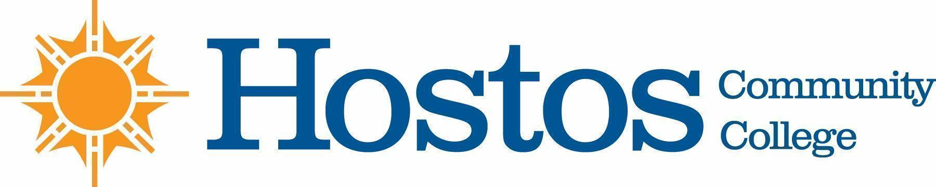

COLLEGE-WIDE CURRICULUM COMMITTEE
MINUTES
TUESDAY, April 20, 2021

PRESENT: Dean Ann Mester
Professor Sherese Mitchell (chair)
Professor Kathleen Doyle
Professor Isabel Feliz
Professor Edward King
Professor Ana Ozuna
Professor Felipe Pimentel
Mr. David Primak
Professor Anne Rounds
Professor Olga Steinberg Neifach
Professor Lisa Tappeiner

Committee members not present: Ms. Silvia Reyes, Mr. Charles Dour

Guests: Profs. Karin Lundberg, Ernest Ialongo, Marcella Bencivenni, Norberto Michel Hernández Valdés-Portela, Nancy Genova, Linda Hirsch, Ms. Johanna Arroyo Peralta, Ms. Wendy Small - Taylor

Meeting began at 3:30 pm

- Acceptance of Agenda

- Minutes of Tuesday, March 23, 2021 meeting were approved

- ESL presentation with Karin Lundberg

- Curriculum Items:

Behavioral & Social Sciences

Course change ECO 101
ECO 102

Vote Results
Yes 11 No 0 Abstain 0

New course HIS 212

Vote Results
Yes 11 No 0 Abstain 0

Course change PPA 111

Vote Results
Yes 11 No 0 Abstain 0

Natural Sciences

Course change BIO 140
BIO 141

Vote Results
Yes 11 No 0 Abstain 0

- Informational: “Proposal to Establish an “A.A. Degree in Liberal Arts & Science Unit” within the Office of Academic Affairs for the administration of the A.A. Degree in Liberal Arts & Science” -- Dean Mester and Professor Linda Hirsch

- Liaison duties roles: As liaisons from this committee to departments, your role is to make sure necessary revisions to documents are made in your department and re-submitted by the next day.

- Adjournment:

There being no further business, the meeting of the College-Wide Curriculum Committee was adjourned at 4:40 p.m.

The next meeting of the College-Wide Curriculum Committee is scheduled for Tuesday, May 4, 2021, at 3:30 p.m. via Zoom.

Respectfully submitted,

Professor Lisa Tappeiner

