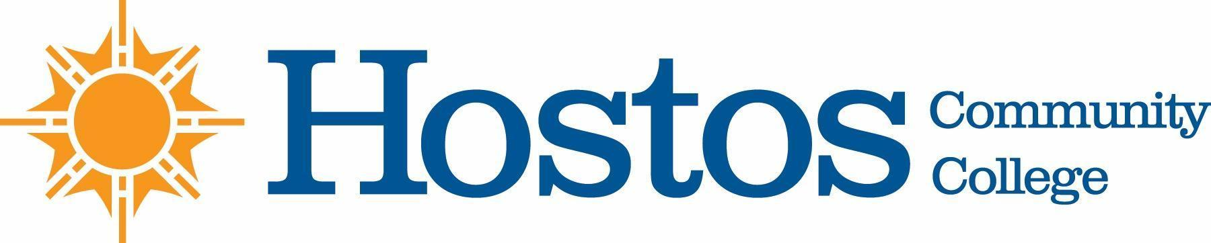

COLLEGE-WIDE CURRICULUM COMMITTEE
MINUTES
TUESDAY, NOVEMBER 17, 2020

PRESENT: Dean Ann Mester
Ms. Johanna Arroyo Peralta
Professor Jacqueline DiSanto
Professor Kathleen Doyle
Professor Isabel Feliz
Professor Sandy Figueroa
Professor Edward King
Professor Ana Ozuna
Mr. David Primak
Ms. Silvia Reyes
Professor Anne Rounds
Ms. Wendy Small-Taylor
Professor Olga Steinberg Neifach
Professor Lisa Tappeiner

Professor Sandy Figueroa, Chair, called the meeting to order at 3:32

Announcements:
- The spring semester CWCC calendar will be shared at the last meeting of the semester on Tuesday, December 1.
- In absence of a standardized syllabus template, a process for recommending language related to Accessibility Resources will be discussed by the Curriculum Steering Committee (Mester, Arroyo, Small-Taylor, Figueroa). Recommendations forthcoming.
- Thanks to Prof. Rounds who consulted with the Natural Sciences faculty this semester.
- Election of new chair of CWCC will take place in February due to retirement of Professor Figueroa.

Minutes
There were no minutes for November 3rd because the meeting was cancelled. The minutes of Tuesday, October 20, 2020, were approved as presented.

Curriculum Items:
Voting Item:
Education
Health Education Unit
Course Revision: HLT 103, 111
Vote Results
Yes 12 No 0 Abstain 0

Course Revision: HLT 120
Vote Results
Yes 12 No 0 Abstain 0

Course Revision: HLT 124
Vote Results
Yes 12 No 0 Abstain 0

New business:
Professor Doyle announced the appearance of new Mathematics courses in the latest Academic University Report.

Professor Figueroa and Dean Mester suggested that English and Math departments create tools to explain recent changes in course structure to assist students and advisors with registration, and departments in determining prerequisites.

Ms. Reyes will present a grid which is currently in development at the December 1st CWCC meeting.

Adjournment
There being no further business, the meeting of the College-Wide Curriculum Committee was adjourned at 4:17 p.m.

The next meeting of the College-Wide Curriculum Committee is scheduled for Tuesday, December 1, 2020, at 3:30 p.m. via Zoom.

Respectfully submitted,

Professor Lisa Tappeiner

