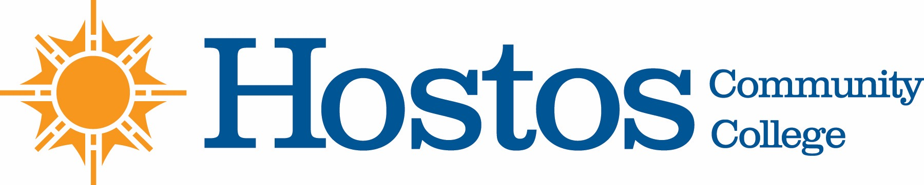

COLLEGE-WIDE CURRICULUM COMMITTEE
AGENDA
TUESDAY, MARCH 2, 2021

- Acceptance of Agenda

- Minutes of Tuesday, February 16, 2021

- Curriculum Items:
EDUCATION

Course change EDU 226
Course change GERO 101
Course change GERO 103

BEHAVIORAL & SOCIAL SCIENCE

Course change CJ 250
Course change LAW 202
Program change Public Interest Paralegal AAS Pathways

NATURAL SCIENCES

Course change BIO 110
Course change BIO 111
Course change BIO 210
Course change BIO 230
Course change CHE 105
Course change CHE 110

HUMANITIES

Course Change GD 105

- Informational Items:

MATHEMATICS
MathEd Articulation

BEHAVIORAL AND SOCIAL SCIENCE
Public Policy and Administration

- Other Business

