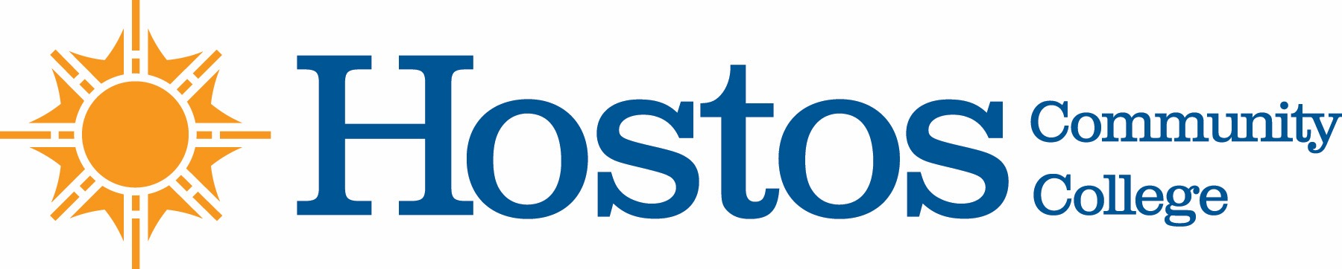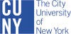

COLLEGE-WIDE CURRICULUM COMMITTEE
AGENDA
Tuesday, May 4, 2021

- Acceptance of Agenda

- Minutes of Tuesday, April 20, 2021

- Fall 2021 CWCC Calendar (Pre & Post Revisions)

- Curriculum Items:

Behavioral & Social Sciences

Pathways SOC 142

PSY 142

Natural Sciences

Program Revision Food Studies

Humanities

Course Change COM 110

New Course ASL 101
SPA 110

Mathematics
Course change MAT 100SI
MAT 19
MAT 119

New Course MAT 120SI

Liberal Arts Options
    - Interdisciplinary Studies in Human Behavior and Social Institutions
    - Psychology
    - Social Work

- Informational
  - Articulation—HCC and NYC College of Technology

