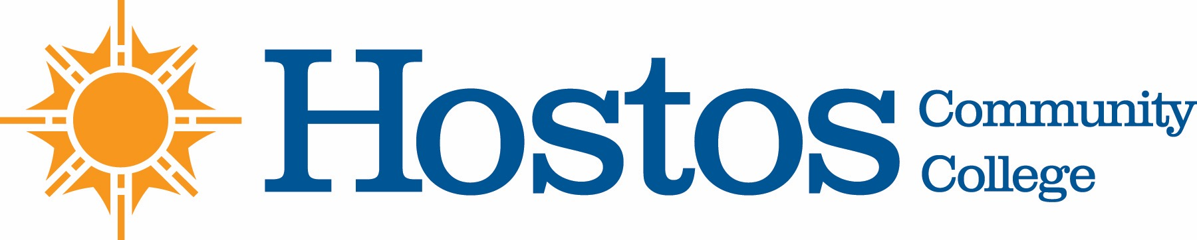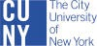

COLLEGE-WIDE CURRICULUM COMMITTEE
AGENDA
TUESDAY, NOVEMBER 2, 2021

- Acceptance of Agenda

- Minutes of Tuesday, October 19, 2021

- Curriculum Items:

LIBERAL ARTS & SCIENCE A.A. OPTIONS

Option Change Black Studies
Community Health
Physical Education Science Option
Physical Education Teacher Option

Program Change Liberal Arts & Science A.A. Options

NATURAL SCIENCES

Program Change AS degree in Liberal Arts and Sciences program

MATHEMATICS

New Courses CMT 100, 110, 140, 150, 160, 200, 240, 250, 260, and 270

- Other Business
Information for Curricular Items
Senate Minutes regarding CWCC
Newest Members

