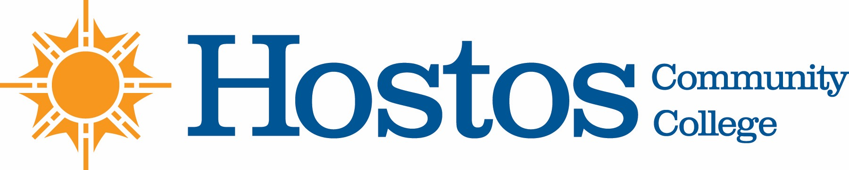

COLLEGE-WIDE CURRICULUM COMMITTEE
AGENDA
TUESDAY, APRIL 7, 2020

- Acceptance of Agenda

- Announcements

- Minutes of Tuesday, March 3, 2020

- Curriculum Items:
Language and Cognition
Course Revision: LIN 105 Language and Power

Natural Sciences
Course Revisions: ENV 111
ENV 121
FS 101
FS 200
FS 220

New Courses: FS 130 Food, Culture, and Health
FS 140 Urban Agricultural Systems

Food Studies Program Revision for Pathways

Mathematics
AS Computer Science Program Revision

Behavioral/Social Sciences Program Revision
AAS Degree Revision with Health Care Administration Concentration

Liberal Arts Option
AA Social Science Option
AA Women’s and Gender Studies Option
AA Latin American and Caribbean Studies Option
AA Community Health Option

- Other Business

