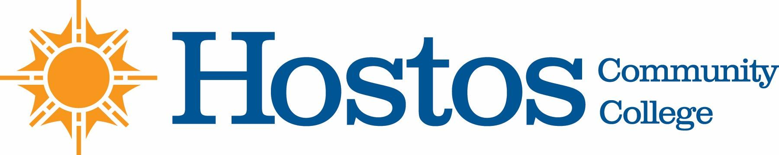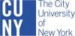

Academic Standards Committee
MINUTES-- DRAFT
Monday – November 6, 2023 @ 4 pm

PRESENT: 1. Sara Rodberg, ASAP, HEO (Out-going Chair, on leave fall 2023 semester)
2. Edward King, Nursing
3. Anna Manukyan, Natural Sciences
4. Clara Nieto-Wire, Mathematics
5. Elizabeth Porter, English
6. Salim Rayman, Allied Health Sciences
7. Zvi Ostrin, Natural Sciences
8. Michael Cisco, English
9. Michael Martinez, HEO

- Acceptance of Agenda – Student Appeal by K.G.

Student seeks to appeal three grades from Fall 2019:

XRA 110 | Radiograph 1 | Prof. M. Livingston | Grade – C  (73.2%)
XRA 112 | Radiologic Physics | Prof. S. Arya | Grade – D  (65.6%)
XRA 114 | Professional Practice Issues in Diagnostic Imaging | Prof. R. Chelladurai | Grade – C (74.15%)

- Draft of KG’s Statement is attached. Upon approval by the ASC, it will be sent to the student, KG, for approval that it accurately states the basis of her Appeal.
- Draft was e-mailed to ASC members on 11-6-2023 for approval

