COLLEGE-WIDE CURRICULUM COMMITTEE
HYFLEX in B502 and Online Meeting, CLICK THIS LINK TO JOIN
Tuesday, October 17, 2023
3:30-5:00 pm
Agenda
- Call to Order
- Acceptance of CWCC agenda for meeting 17 October 2023 (see link to agenda)
- Approval of CWCC minutes for meeting 26 September 2023 (see link to minutes)
- Curricular Items – To be voted on
  - HUM 100 – Course Change
    - HUM 100 Introduction to Global Humanities. Correcting for accuracy in the prerequisites: “Pre- or Corequisite: ENG 100 or ESL 91 or higher; or SPA 121 or Spanish ​placement if offered in Spanish” (see link to form); Professors Nicole Wallenbrock and Ana Ozuna (Humanities) presenting -CLICK THIS LINK TO VOTE (only open during vote)- https://forms.gle/XAVYadnzt9iiZQAA9
  - SPA 101 and SPA 111 – Course Change and New Course
    - Course Change SPA 101 Elementary Spanish I. Modern Languages Unit would like to divide the current SPA 101 4 credit course into a 3 credit SPA 101 lecture and a 1 credit SPA 111 language laboratory (see link to form); Professors Nicole Wallenbrock and Ana Ozuna (Humanities) presenting -CLICK THIS LINK TO VOTE (only open during vote)- https://forms.gle/43om4ByUmy8XWG8U9
    - New Course SPA 111 Elementary Spanish I (Laboratory). Modern Languages Unit would like to divide the current SPA 101 4 credit course into a 3 credit SPA 101 lecture and a 1 credit SPA 111 language laboratory (see links to form and syllabus); Professors Nicole Wallenbrock and Ana Ozuna (Humanities) presenting -approved at Senate on 18 May 2023
  - Question: Will students’ ability to register for courses such as HUM 100 in Spanish be affected by the College Language Policy, which specifies students take content courses in English? page 187 of the College Catalog: https://issuu.com/hostoscollege/docs/2022-2023_college_catalog_-_hostos_community_colle/188
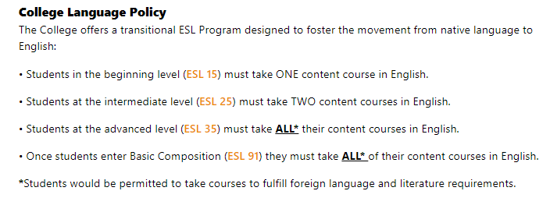
- Announcements and Resources
  - Resource: Flowcharts for ESL, ENG, MAT gateway courses Flowcharts NEW ESL ENG MAT 2022 Fall.pdf
  - Resource: CWCC membership Fall 2023
Dean Babette Audant, Provost's Designee
Denise Cummings Clay, Education
Kathleen Doyle, Mathematics
Nancy Genova, Behavioral and Social Sciences
Linda Ridley, Business, Recording Secretary
Christine Hutchins, English, Chair
Karin Lundberg, Language & Cognition
Ana Ozuna, Humanities
David Primak, Registrar
Silvia Reyes, Office of Academic Affairs, HEO
Wendy Small-Taylor, Curriculum Office
Olga Steinberg, Natural Sciences
Jarek Stelmark, Allied Health Sciences
Haruko Yamauchi, Library
TBA, SGA
TBA, SGA

  - Resource: CWCC meetings Fall 2023
All meetings at 3:30 hybrid in room B502 or at https://hostos-cuny-edu.zoom.us/j/6756681908

Fall 2023 Detailed Curriculum Schedule (link here)​

CWCC | SEC | Senate
 | September 13 | September 21
September 26 | October 11 | October 19
October 17
October 31 | November 8 | November 16
November 14
November 28 | December 13 | December 21

- Adjournment

Christine Hutchins is inviting you to a scheduled Zoom meeting
Topic: CWCC Meeting
Time: This is a recurring meeting

Join Zoom Meeting
https://hostos-cuny-edu.zoom.us/j/6756681908

Meeting ID: 675 668 1908
One tap mobile
+16465588656,,6756681908# US (New York)
+13017158592,,6756681908# US (Washington DC)

Dial by your location
+1 646 558 8656 US (New York)
+1 301 715 8592 US (Washington DC)
+1 312 626 6799 US (Chicago)
+1 346 248 7799 US (Houston)
+1 669 900 9128 US (San Jose)
+1 253 215 8782 US (Tacoma)
Meeting ID: 675 668 1908
Find your local number: https://hostos-cuny-edu.zoom.us/u/kdkYWLRhGs

Join by SIP
6756681908@zoomcrc.com

Join by H.323
162.255.37.11 (US West)
162.255.36.11 (US East)
213.19.144.110 (Amsterdam Netherlands)
213.244.140.110 (Germany)
103.122.166.55 (Australia Sydney)
103.122.167.55 (Australia Melbourne)
69.174.57.160 (Canada Toronto)
65.39.152.160 (Canada Vancouver)
207.226.132.110 (Japan Tokyo)
149.137.24.110 (Japan Osaka)
Meeting ID: 675 668 1908

