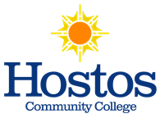
Flexible Grading Policy – Information
Financial Aid
Advisors

- Students should seek guidance from financial aid if considering the CR/NC option to
discuss implications on meeting financial aid requirements.
- Contact Office of Financial Aid: finaid@hostos.cuny.edu, 718-518-6555
Student Success
Coaches

- Students should seek guidance from student success coaches to consider implications of the
CR/NC option for specific courses relevant to future career, graduate or professional
Training requirements.
- Contact SSCU: SSCU@hostos.cuny.edu, 718-664-2560 from 9-5pm Mon-Fri
Deadlines

- Last day to file for CR/NC option: January 12, 2021
- For information on the CR/NC option, contact the Office of the Registrar at:
grades@hostos.cuny.edu, 718-518-6771 from 9-5pm Mon-Fri

