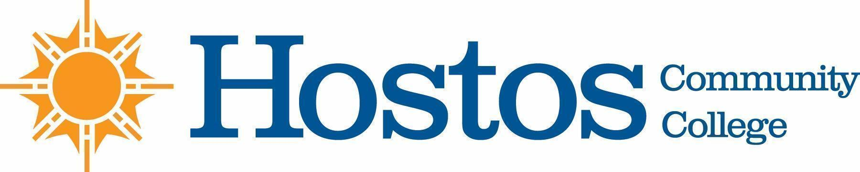

COLLEGE-WIDE CURRICULUM COMMITTEE
MINUTES
TUESDAY, March 23, 2021

PRESENT: Dean Ann Mester
Professor Sherese Mitchell (chair)
Mr. Charles Dour (SGA student rep)
Professor Isabel Feliz
Professor Edward King
Professor Ana Ozuna
Mr. David Primak
Ms. Silvia Reyes
Professor Anne Rounds
Professor Olga Steinberg Neifach
Professor Lisa Tappeiner

Committee members not present: Profs. Kathleen Doyle, Felipe Pimentel

Guests: Profs. Emmanuel Velayos Larrabure, Jung Hang Lee, Inmaculada Lara-Bonilla, Ms. Wendy Small – Taylor, Ms. Johanna Arroyo Peralta

Meeting began at 3:30 pm

- Acceptance of Agenda

- Minutes of Tuesday, March 16, 2021 meeting were approved

- Other business -- share curricular items with your department. Bring items for discussion from your department to this committee. You are the voice of your department in the CWCC.

Get items on the agenda early.

Any items submitted from this meeting forward will not be on the fall CUNY calendar. They will be implemented in Spring 2022.

- Curriculum Items:

MATHEMATICS

Pathways MAT 150 & MAT 150 SI

Vote Results
Yes 10 No 0 Abstain 0

HUMANITIES

Course change LAC 202
LAC 216
LAC 244
LAC 252
LAC 262
LAC 290
LAC 350
LAC 360

Vote Results
Yes 11 No 0 Abstain 0

Pathways BLS 202
BLS 123

Vote Results
Yes 11 No Abstain

New Course LAC 160

Vote Results
Yes 10 No Abstain

- Adjournment:

There being no further business, the meeting of the College-Wide Curriculum Committee was adjourned at 4:48 p.m.

The next meeting of the College-Wide Curriculum Committee is scheduled for Tuesday, April 20, 2021, at 3:30 p.m. via Zoom.

Respectfully submitted,

Professor Lisa Tappeiner

