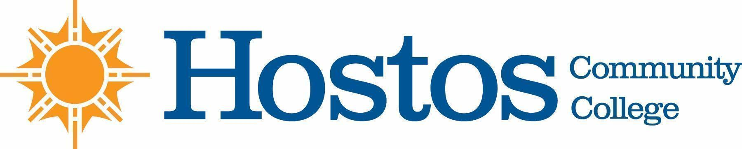

COLLEGE-WIDE CURRICULUM COMMITTEE
MINUTES

TUESDAY, May 4, 2021

PRESENT: Dean Ann Mester
Professor Sherese Mitchell (chair)
Mr. Charles Dour
Professor Kathleen Doyle
Professor Isabel Feliz
Professor Edward King
Professor Ana Ozuna
Professor Felipe Pimentel
Mr. David Primak
Ms. Silvia Reyes
Professor Anne Rounds
Professor Olga Steinberg Neifach
Professor Lisa Tappeiner

Guests: Ms. Johanna Arroyo Peralta, Ms. Wendy Small-Taylor, Profs. Linda Anderson, Sarah Hoiland, Eugena Griffin, Oliver Crespo, JungHang Lee, Humberto Ballesteros, Alisa Roost, Linda Hirsch, Antonios Varelas, Nicole Wallenbrock, Marta Rivera

Meeting began at 3:30 pm

- Acceptance of Agenda

- Minutes of Tuesday, April 20, 2021 meeting were approved

- Curriculum Items:

Behavioral & Social Sciences

Pathways SOC 140

Vote Results
Yes 11 No 0 Abstain 0

PSY 142

Vote Results
Yes 11 No 0 Abstain 0

Natural Sciences

Program Revision Food Studies

Vote Results
Yes 11 No 0 Abstain 0

Humanities

Course Change COM 110

Vote Results
Yes 11 No 0 Abstain 0

New Courses ASL 101

Vote Results
Yes 11 No 0 Abstain 0

SPA 110
Vote Results
Yes 10 No 0 Abstain 0

Mathematics
Course change MAT 100SI
MAT 19
MAT 119
Vote Results
Yes 10 No 0 Abstain 0

New Course MAT 120SI

Vote Results
Yes 10 No 0 Abstain 0

Information Item - Articulation Presentation Mathematics Department — HCC (Electrical Engineering) to NYC College of Technology (Computer EngineeringTechnology)

5. Liberal Arts Options
    - Interdisciplinary Studies in Human Behavior and Social Institutions
    - Psychology
    - Social Work
Vote Results
Yes 10 No 0 Abstain 0

6. Adjournment:

There being no further business, the meeting of the College-Wide Curriculum Committee was adjourned at 5:00 p.m.

The next meeting of the College-Wide Curriculum Committee is scheduled for Tuesday, August, 31 2021, at 3:30 p.m. via Zoom

Respectfully submitted,

Professor Lisa Tappeiner

