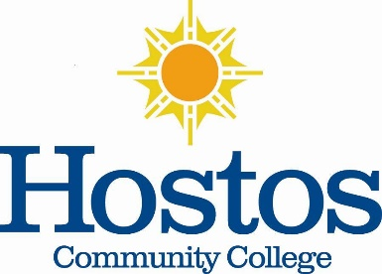

**Institutional Research Committee**

Hostos Community College/The City University of New York

475 Grand Concourse, Bronx, New York 10451

**MINUTES**

February 9, 2024, 2:00 p.m. – Meeting Location: Zoom

**Members Present**: Jason Buchanan, Denise Cummings-Clay, Juang Hang, _____________ Lee, A. J. Stachelek, Vitus Tindana, and Victor-Torres-Velez. **Absent:** Helen Chang? Soheli Choudhury? Student Rep., Piotr Kock, Michel Portela? and Emily Tenzer Sautoro?

1. **Call to Order** – Dr. Jason Buchanan, Institutional Research Committee (IRC) Chair (2020-2023), called the meeting to order at 2:04 p.m. There was a quorum.
2. **Minutes** – The Minutes of the previous meeting, May 9, 2023, were not reviewed. They are to be reviewed at the next meeting.
3. **IRC Leadership –** Dr. Buchanan indicated that the purpose of the meeting was to elect a new Chair. He entertained nominations for Chair. Denise Cummings-Clay nominated A. J. Stachelek. The nomination was seconded by Juan Hang. No other nominations were made. It was moved and seconded that the nominations be closed. The group approved by common consent. An online voting poll was opened. By secret vote submissions, six (6) approved of the nomination, zero (0) were against, and three (3) were not present to vote including a student representative. A. J. Stachelek was elected Chair unanimously.

Members expressed their gratitude to Dr. Buchanan for his service during the last term. Dr. Stachelek indicated that he would send a poll to the committee soon to schedule a meeting. The action is to select a mutually agreeable meeting time for members and to give all committee members an opportunity to select a Secretary and proceed with committee work.

1. **Adjournment** – The IRC meeting adjourned at 2:19 p.m.

Respectfully submitted, Denise Cummings-Clay, Ph.D., Secretary, IRC (2020-2023)

