
Eugenio María de
Hostos Community College
The City University of New York

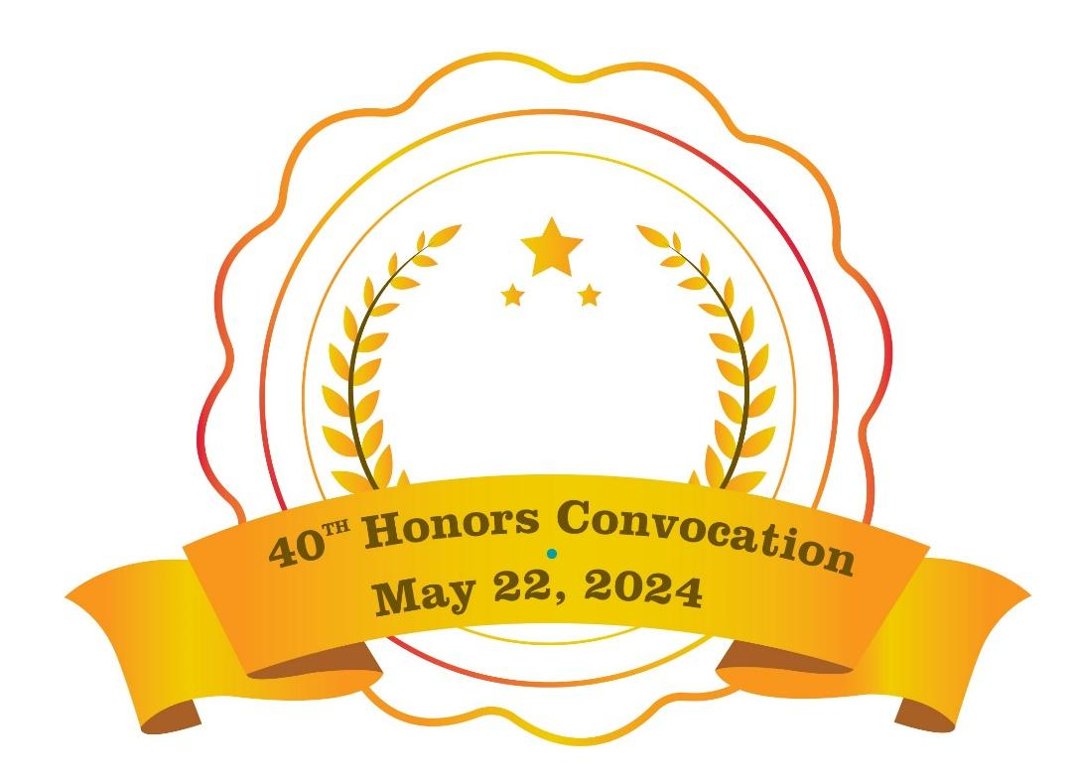
A special celebration of students’ academic
excellence and achievements

Hostos Main Theater
6:00 P.M.

The Division of Academic Affairs
proudly presents

The Eugenio María de Hostos Community College
of The City University of New York

Fortieth Annual Honors Convocation
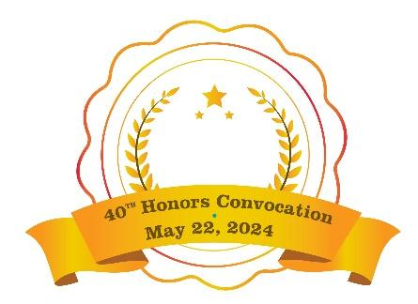
Wednesday the twenty-second day of May
in the year two thousand twenty-four
at six o'clock in the evening

Honors Convocation is a collaboration between
Office of Academic Affairs and
Senate Scholarship and Awards Committee.

The ceremony is made possible
by significant sponsorship from:
Office of the President
Division of Administration and Finance
Division of Student Development and Enrollment Management
Division of Institutional Advancement

Thank you!

COLLEGE LEADERS

Daisy Cocco De Filippis
Hostos President

Shiang-Kwei Wang
Vice President and Provost for Academic Affairs

Esther Rodríguez-Chardavoyne
Senior Vice President for Administration and Finance

La Toro Yates
Vice President for Student Development and Enrollment Management

Colette Atkins
Vice President for Institutional Advancement

Evelyn Fernández-Ketcham
Vice President for Continuing Education and Workforce Development

Diana Kreymer
Executive Chief of Staff

Babette Audant
Dean of Academic Affairs and Institutional Effectiveness

EXTENDED CABINET
Ana I. García Reyes
Dean of Community Relations

Eugene Sohn
Executive Counsel and Labor Designee

Philip Oliveri
Chief Diversity Officer, Title IX Coordinator and ADA/504 Coordinator

Eric Radezky
Director of Governmental and External Affairs

Sofia Oviedo
Research Programs Director

Dilawar Grewal
Assistant Vice President of Information Technology and Chief Information Officer

Ivano Leoncavallo
Director of Communications

Division of  Academic Affairs |  | Division of Student Development  and Enrollment Management
Andrea Fabrizio  Associate Dean for Academic Affairs  Sarah Brennan  Assistant to the Vice President and Provost |  | Althea Sterling  Associate Dean of Student Development and Enrollment Management  Johanna Gómez  Assistant Dean of Student Development

THANK YOU!

Senate Scholarships and Awards Committee
Ronette Shaw, Co-Chair, Allied Health Sciences
Rodney Blair, Co-Chair, Allied Health Sciences
Marina Esquilin, Secretary, Scholarship Office, HEO
Traveras Geter, Office of School College Partnership
Myriam Cadet, Allied Health Sciences
Joseph Gyan, Business
Asrat Amnie, Education
Jennifer Sabour, English
Humberto Ballesteros, Humanities
Yoel Rodriguez, Natural Sciences
Yaxleny Hernandez, Student

Ceremony Planning Team
Sarah Brennan, Chair, Academic Affairs
Su Ng, Administration and Finance
Claudia Hernández, Institutional Advancement
Felix Arocho, Institutional Advancement
Greg Brown, Institutional Advancement
Wilfredo Burgos-Matos, President’s Office
Marina Esquilín, Student Development
Johanna Gómez, Student Development
Andrea Fabrizio, Academic Affairs
Yana He, Academic Affairs
Silvia Reyes, Academic Affairs
Jerry Rosa, Student Development
Kelsey Schmitz, President’s Office
Eileen Will, Academic Affairs

Ceremony Narrator/Mistress of Ceremonies
Silvia Reyes

Ceremony Announcers
Babette Audant
Andrea Fabrizio

Collaborating Offices
Conference Center
Hostos Center for the Arts & Culture
Printing Center
Public Safety

Funding Sponsors
Office of the President
Division of Administration and Finance
Division of Academic Affairs
Division of Institutional Advancement

PROGRAM
NATIONAL  ANTHEM |  | Marie Inamorie, Pianist  Meghan Campos, Vocalist
GREETINGS |  | Daisy Cocco De Filippis  President of Hostos Community College
PRESIDENT’S STUDENT LEADERSHIP AWARDS |  | Daisy Cocco De Filippis  President of Hostos Community College
FOUNDATION AND DONOR AWARDS |  | Colette Atkins  Vice President for Institutional Advancement and Executive Director of the Hostos Foundation
DEPARTMENT  AWARDS |  | Allied Health Sciences, Behavioral/Social Sciences, Business, Education, English, Humanities,  Language and Cognition, Library, Mathematics, Engineering, Natural Sciences
SPECIAL  PROGRAM  AWARDS |  | ASAP, BMI, CSTEP, Hostos Athletics,  Hostos Leadership Academy,  Office of School College Partnerships
CLOSING  REMARKS |  | Shiang-Kwei Wang, Vice President  and Provost for Academic Affairs
MISTRESS OF CEREMONY |  | Silvia Reyes, Director of Special Programs  and Student Engagement
ANNOUNCERS |  | Babette Audant, Dean for Academic Affairs  Andrea Fabrizio, Associate Dean for Academic Affairs

PRESIDENTIAL AWARDS

President’s Student Leadership Award
Ansumana Jammeh, SGA Senator
Jae’oni Davis, Scholar Student-Athlete
John Santana, SGA Senator
Miriam Fidelis, SGA Senate Secretary
Orlando Soto, SGA VP of Academic Affairs/Chair of Senate
Recognizing outstanding graduating students who serve in the SGA or Athletics and have a 3.5 G.P.A. or better.

FOUNDATION AND DONOR AWARDS
Valedictorian and Salutatorian of the Graduating Class of 2024
Valedictorian | Salutatorian
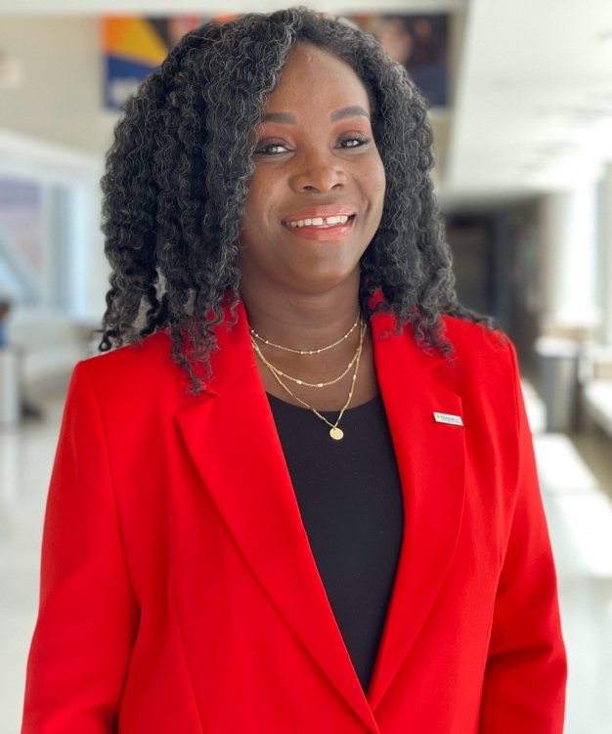 | 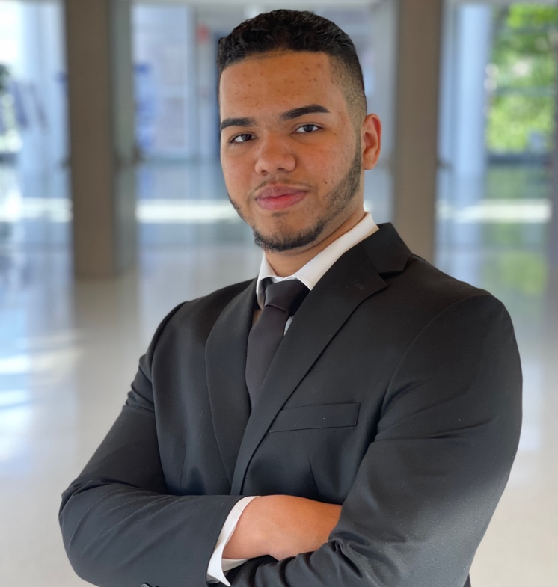
Tiffany Wilson  A.S. in Business Management | Reylin Elier Rivera Paulino  A.A.in Liberal Arts and Sciences
The Hostos Foundation provides scholarships to the Valedictorian and the Salutatorian, both of whom represent the highest performing students of the graduating class. These students maintained excellence in academics, leadership and service within Hostos Community College and in the community.

DONOR AND FOUNDATION SCHOLARSHIPS & AWARDS
Please see insert for the names of student honorees

The Cocco De Filippis Family Scholarship
Raquel Baez
Franyeli Contreras
Kyra Echeverria
Kimberly Feble
Miriam Fidelis
Halimo Hassen
Ousman Konateh
Alexia Matthew
Stephanie Oliveira De Araujo
Joseph Parker
Samiya Rifat
Nene Tall
This merit-based scholarship is awarded annually to two students with demonstrable community engagement and academic achievement who intend to use their degree to empower their community. The scholarship is awarded to fully matriculated students who have completed at least one semester. The recipients have demonstrably significant community service and a minimum G.P.A. of 3.0.

The John Anthony Chardavoyne Scholarship Endowment
Ansumana Jammeh
Stephanie Oliveira De Araujo
“In memory of Mr. Chardavoyne’s life-long desire to learn and spread joy,” this scholarship is awarded to two graduating Liberal Arts and Sciences students in the History Option sequence. The honorees have a concentration in historical studies, have a minimum G.P.A. of 3.0, and are continuing to a four-year college degree program. They have also demonstrated community service.

The Dr. Nasry Michelen Memorial Endowment
Tasha Cage
Ousman Konateh
Olowatobi Odofa Aboyeji
Merouane Sabri
Zhimin Wei
This scholarship helps to defray the cost of tuition, fees and other college-related expenses for students who are enrolled full-time in an A.A.S. Allied Health degree program, have a minimum G.P.A. of 3.5, and have demonstrated community service.

The Professor Isabel Li Endowed Memorial Scholarship
Miriam Fidelis
Pamela Paniagua
The Professor Isabel Li Endowed Memorial Scholarship provides financial resources to help two graduating Hostos students who intend to continue their education and earn a bachelor’s degree at a four-year institution.

The Joe Alicea Veterans Scholarship
Jason Clarke
Yassir Djoussa
Joe Alicea worked at Hostos for more than 39-years in the Office of Financial Aid and served our country in the Vietnam War. To honor his memory, the Division of Student Development and Enrollment Management (SDEM) has established the college's very first scholarship fund dedicated to student veterans who have served our nation.

The Paula L. Zajan Early Childhood Education Scholarship
Sashee Caraballo
Javon Cole
Dr. Paula Zajan, professor and founder of the Early Childhood Education Program, died in June 1988. Dr. Zajan was a dedicated teacher who imparted her love of learning and teaching to students. She bequeathed to the college funds to start a scholarship in her name. Dr. Zajan loved life and people and saw beauty in individuals from all walks of life. She was very devoted and committed to the Early Childhood Education Program and to Hostos Community College. Her contributions have enriched the lives of many students. Her magnificent spirit continues in the legacy she left behind.

DEPARTMENTAL AWARDS
Allied Health Sciences Department

Dental Hygiene Awards
Bronze Award Anniska Wallace
The Bronze Award is given in recognition of the academic achievement of having the third highest G.P.A. in the class.

Silver Award Mame Goumbala
The Silver Award is given in recognition of the academic achievement of having the second highest G.P.A. in the class.

Gold Award Maria Benny
The Gold Award is given in recognition of the academic achievement of having the highest G.P.A. in the class.

Licensed Practical Nursing (Day Program) Awards
Bronze Award Rosalba Puntiel
The Bronze Award is awarded to the student with the third highest G.P.A. in the Licensed Practical Nursing Day program.

Silver Award Evelin Rosario Castillo
The Silver Award is given in recognition of the academic achievement of having the second highest G.P.A. in the Licensed Practical Nursing Day program.

Gold Award Alejandra Sena
The Gold Award is given in recognition of the academic achievement of having the highest G.P.A. in the Licensed Practical Nursing Day program.

Licensed Practical Nursing (Evening Program) Awards
Bronze Award Jarinet Pena
The Bronze Award is awarded to the student with the third highest G.P.A. in the Licensed Practical Nursing Evening program.

Silver Award Velvet Reed
The Silver Award is given in recognition of the academic achievement of having the second highest G.P.A. in the Licensed Practical Nursing Evening program.

Gold Award Jermelia N Clarke
The Gold Award is given in recognition of the academic achievement of having the highest G.P.A. in the Licensed Practical Nursing Evening program.

Registered Nursing (Day Program) Awards
Bronze Award Antoinette Sawadogo
The Bronze Award is given in recognition of the academic achievement of having the third highest G.P.A. in the Registered Nursing Day program.

Silver Award Julissa Hernández
The Silver Award is given in recognition of the academic achievement of having the second highest G.P.A. in the Registered Nursing Day program.

Gold Award Joseline Fernández
The Gold Award is given in recognition of the academic achievement of having the highest G.P.A. in the Registered Nursing Day program.

Registered Nursing (Evening Program) Awards
Bronze Award Nicollette Marie Suarez
The Bronze Award is given in recognition of the academic achievement of having the third highest G.P.A. in the Registered Nursing Evening program.

Silver Award Rebecca Miller
The Silver Award is given in recognition of the academic achievement of having the second highest G.P.A. in the Registered Nursing Evening program.

Gold Award Lam Hoang Dang
The Gold Award is given in recognition of the academic achievement of having the highest G.P.A. in the Registered Nursing Evening program.

Radiologic Technology Awards
Bronze Award Faouzia Affo-Wabo
Presented to the students who have achieved the third highest G.P.A. in the Radiologic Technology program.

Silver Award Joceline Limon
Presented to the student who has achieved the second highest G.P.A. in the Radiologic Technology program.

Gold Award Tasnim Sharif
Presented to the student who has achieved the highest G.P.A. in the Radiologic Technology program.

Behavioral and Social Sciences Department
Behavioral and Social Sciences Awards
Excellence in Behavioral Sciences
Annalie Vega Alfonso
Christopher Yenchko
Gladys Morales

Public Policy and Law Awards
Excellence in Criminal Justice
Danny Acosta Mane
Kevin Lara

Excellence in Healthcare Administration Award
Mario Cacho

Excellence in Paralegal Award
Marquini Gil

Excellence in Public Policy and Administration Award
Jonathan Sanchez

Social Sciences Awards
Excellence in Economics 101
Zachary Tyler Boutoille

Excellence in Economics 102
Jose Miguel Gonzalez

Excellence in History 201
Linabell Castillo

Excellence in History 202
Nicole Pirraglia

Excellence in History 210
Carmen Julia Roque Escarfullleri

Excellence in History 211
Christopher Yenchko

Excellence in Political Science 101
Marlin Javier

Business Department
A.A.S. in Accounting Awards
Bronze Award Nicole Rodriguez Alcantara
Silver Award Gregory Estevez Morrero
Gold Award Yokasta Fernandez

A.S. in Accounting Award
Bronze Award Keylee Arroyo
Silver Award Edgar Hernandez Sanchez
Gold Award Gisselle Santana

A.S. in Business Management Awards
Bronze Award Luis Rivera
Silver Award Iana Romanova
Gold Award Karina Garcia

A.A.S. in Office Technology Awards
Bronze Award Ryan Pleasant
Silver Award Christine Chavarria
Gold Award Fawza Ibrahim Gado
The Office Technology Program Awards are presented to graduating students demonstrating outstanding academic achievement. A bronze, silver, or gold medal is presented to the student with the third, second, or highest G.P.A.

Education Department
Aging and Health Studies/Gerontology Awards
Honorable Mention Francine Estrada

Bronze Award Christine Jessop
This award is given to the graduating student in the Aging and Health Studies program with the third highest overall G.P.A.

Silver Award Alden Hall
This award is given to the graduating student in the Aging and Health Studies program with the second highest overall G.P.A.

Gold Award Geraldine Nunez
This award is given to the graduating student in the Aging and Health Studies program with the highest overall G.P.A.

Health Education Awards
Honorable Mention Sohemabanu Shaikh
Bronze Award Raquel María Báez García
Silver Award Cristina Moya
Gold Award Nellyta Jean

Physical Education Awards
Excellence in Physical Education
Luisiana Marmolejos Acosta

Teacher Education Awards
Honorable Mention Gianna Pascal
Bronze Award Sandrine Ouedraogo
Silver Award Jermel Creekmur
Gold Award Jeannette Garcia

English Department
Women and Gender Studies
Excellence in Women's and Gender Studies Awards
Estefany Paola Ovalles González
Isauris Michele Marmolejos
María Colón
Olimpia Parra
Topanga Padilla
The Women's and Gender Studies program is pleased to recognize Academic Excellence in Women's and Gender Studies. Outstanding essays or projects are submitted for nomination by faculty who are teaching courses that emphasize either discipline-based and/or interdisciplinary perspectives on gender and sexuality. Winners are selected for their ability to reflect on, analyze, and illuminate issues in women's and gender studies as well as for the overall strength of the students’ writing. Recipients carry a G.P.A. of at least 3.0.

Humanities Department
Black Studies Awards
Excellence in Black Studies Awards
Topaz Award Davina Alache
Bronze Award Cynsere Galindez
Silver Award Karesse Baptiste
Gold Award Jean Lewis
Diamond Annalie Vega Alfonso
Awarded to students who excelled in Black Studies

Latin American and Caribbean Studies Awards
Excellence in Latin American and Caribbean Studies
Davina Alache
Javier Corro Campos
Luisiana Marmolejos Acosta
Yamilka Rosario
Awarded to students who excelled in Latin American and Caribbean Studies.

Media Studies Awards
Excellence in Audio Production
Arthur Hayles
Karesse Baptiste
Keannie Paulino
Kimberly Hill
Marie Inamori
Omar De Leon Ramirez

Excellence in Music 101
Salih A. Rahman

Excellence in Music 102
Adrian McCullum
Sophia Helena Navarro Alivio

Modern Language Awards
Excellence in French Amber Lin Demers
Kevin Toxqui-Tomay

Excellence in Italian Iris Angie Toxqui-Tomay
Melissa Torres

Excellence in Japanese
Joshua Wane Wiggan
Manuel Patrick Vivas
Theresa Marie Ross

Excellence in Spanish
Shelsie Bailon
Presented to students who excelled in one of the following: French and Francophone language and culture, Italian language and culture, Spanish and Hispanophone language and culture, and Japanese language and culture.

Visual and Performing Arts Awards
Excellence in Painting and Drawing
Chelsea Miguelina Ramos
Jason Elliot Rodriguez
Zina Mcghie
Awarded to students who have shown remarkable skill and commitment in painting and drawing.

Excellence in a Theater Class
Ariel Padilla
Darius Aaron Lawson
Lady Trejo
Lisset Dominguez
Shantely Garcia
Awarded to students who have shown remarkable skill and commitment in a theater class at Hostos.

Excellence in a Theatrical Production
Dainma Martinez
Diego Alvarado
Hadiya Forde
Jenifel Melendez
Rony Burgos
Tahmina Begum
Awarded to students that have excelled in rehearsal and performance.

Excellence in Visual and Performing Arts
Lisset Dominguez

Library Department Awards
Escriba!/Write! 2023-24 Student Literary and Art Journal Award
Award for Art Zina Mcghie
Award for Writing Isauris Marmolejos

¡Escriba! ¡Write! is multilingual student literary & art journal that the Library has published annually for 18 years. Outstanding work in writing or art is placed in nomination for its originality, technical excellence and ability to capture and present what the students want to convey to readers of the journal.

Mathematics and Natural Sciences Departments
Engineering Awards
Honorable Mention Brando Méndez-Zambrano
Roger Enriquez
Third Place Award Kevin C Dillon
Second Place Award Aaron ArjuneLall
Blerina Sehitaj
First Place John Santana
The Engineering Award is presented to engineering students who have shown high academic achievement and have demonstrated outstanding performance beyond the classroom by participating in STEM-related activities or presenting papers or posters at scientific/engineering meetings. An overall G.P.A. of 3.5 or higher is required. This award is offered by the Mathematics and Natural Sciences Departments.

Mathematics Department
Computer Science Awards
Bronze Award Gladys Hughes
The Bronze Medal Computer Science Award is for outstanding academic growth in Computer Science by a student initially placed in a developmental Mathematics course who has completed at least 8 credits of Mathematics beyond MAT 150, including CSC 205 Discrete Mathematics, with at least a 3.5 Grade Point Average in Computer Science.

Silver Award Emily Checo Genao
The Silver Computer Science Award is for outstanding achievement in Computer Science by a graduating student who has completed at least 6 credits beyond Mat 160, including CSC 215 Modern Programming, with at least a 3.5 Grade Point Average in Computer science.

Gold Award Gladys Medina de Muñoz
The Gold Medal Computer Science Award is for outstanding achievement in Computer Science by a graduating student who has completed at least 11 credits beyond MAT 160, including CSC 215 Modern Programming, with at least a 3.5 Grade Point Average in Computer Science.

Mathematics Awards
Bronze Award Carmen Julia Roque Escarfullleri
Silver Award Javier J. Corro Campos
Gold Award Charlie Valencia
Mathematics and Computer Science Scholars (MACSS) Program
Academic Excellence in Computer Science
Gladys Medina De Munoz

Academic Excellence in Mathematics
Carmen Julia Roque Escarfullleri

Natural Sciences Department

Environmental Stewardship Award
Susan Hu
The Environmental Stewardship and Community Service Award is presented to a student in A.A., A.S., Forensic Science, Chemical or Mechanical Engineering Programs with a science G.P.A. of 3.5 or higher and who has demonstrated commitment and leadership in addressing environmental issues in the college and the community.

Food Studies Award
Second Place Narell Vasquez Luque
First Place Josephine Silva
The Food Studies Award is presented to the graduating student who has completed the requirements for the Associate in Science in Food Studies with a grade point average of 3.5 or higher, and who has demonstrated academic excellence, dedication, and leadership in addressing relevant issues within the food system and in supporting the advancement of food justice in the college and the community.

Forensic Science Award
Jared Ramlogan
The Forensic Science Award is presented to a student enrolled in the Forensic Science Dual Degree program who has accumulated 50 or more credits towards an A.S. degree, has a cumulative G.P.A. of 3.5 or higher and/or participated in research activities, such as LSAMP, PRIZM, summer internship, CRSP or others.

Mildred Hernton Award
Bryan Francisco
The Mildred Hernton Award is a posthumous homage to Mrs. Mildred Hernton, a former senior CLT and charter member of the Department of Natural Sciences. The award is presented to a student who has completed at least 16 credits and achieved a G.P.A. of 3.7 or higher in biology as well as an overall G.P.A. of 3.5.

Natural Sciences Award
Afnan Farea
The Natural Sciences Award is a special award given to a student who has shown academic accomplishment by achieving a G.P.A. of 3.5 or higher in science courses and has demonstrated outstanding performance beyond the classroom by participating in departmental activities or research projects, presenting papers or posters at scientific meetings, or demonstrating leadership in other science-related activities.

Women in Science Award
Sor Bello Meléndez
The Women in Science Awards are presented to female students who have completed the requirements for the Associate in Science Degree Program and who have demonstrated dedication, excellence, and leadership in academic and research achievements and achieved a G.P.A. of 3.5 or higher.

SPECIAL PROGRAM AWARDS
Accelerated Study for Associates Program (ASAP)
ASAP Excellence Award
Jason Rodriguez
The ASAP Excellence Award is presented to the ASAP student on track to graduate with the highest GPA in our program, recognizing their exceptional commitment to scholarly achievement and dedication to academic success.

Athletics Department
Scholar Student-Athlete of the Year
Jae'oni Davis

Black Male Initiative (BMI)
BMI Together wE Achieve More Awards (TEAM)
Jose A Keppis
Kevin C Dillon
Sor A Bello Meléndez
The Black Male Initiative – Together wE Achieve More (BMI TEAM) Award is presented to BMI mentors, tutors, and/or peers who have demonstrated academic excellence, commitment to the BMI program and its initiatives, and qualities of leadership. Additionally, the student's ability to address issues relevant to the STEM community at Hostos and/or beyond, including diversity, equity, inclusion, and/or social justice will also be considered. An overall G.P.A. of 3.2 or higher is required.

Collegiate Science and Technology Entry Program (CSTEP)
Certificate of Excellence
Blerina Sehitaj
Gladys Hughes
Julianne Cepero

Hostos Student Leadership Academy
Excellence in Leadership Awards
Brittany Chantel Lanzano
Cynthia Bongo-Remadji
Dainma Martinez
Rzan Albahri
Stacy Delgado
An award to celebrate the accomplishments of a student who excels in volunteering and attends leadership training workshops throughout the fall, winter and spring. The student demonstrates and exhibits the qualities exuded in the CUNY Star Model for Leadership Development.

The 31st Annual National Character & Leadership Symposium (NCLS) at the United States Air Force Academy Participant Awards
Kobe Bryant Jacobs
Yaxeny Hernandez-Ravelo
An award for a student who participates in the 31st Annual National Character and Leadership Symposium as a representative of Hostos Community College and demonstrates the values associated with the Hostos Honor Oath.

Phi Theta Kappa All-New York Academic Team Awards
Blerina Sehitaj
Stacy Delgado
Student who exemplifies excellence inside and outside the classroom through service and scholarship as a member of Phi Theta Kappa.

Office of School College Partnerships (OSCP)
College Now Awards
Academic Excellence and Pathway Award
Khulud Alhirdi
This award is for student(s) who has earned the most college credits while still in high school and has the highest G.P.A. from those credits earned.

Hostos Lincoln Academy Awards
Academic Excellence Award
Alexa Leiva
Fatima Bashir
Kadijatou Dukureh
Kailani Gaynor
Leya Crum-Ewing
Mady Keita
Tamara Dilemuth
These students from Hostos-Lincoln Academy of Science, a CUNY Early College Initiative high school, are graduating from high school at the same time as they are receiving an Associate in Arts Degree from Hostos Community College. These students completed this incredible accomplishment and maintained a 3.7 or higher GPA. These students can transfer directly into a senior college with at least 60 credits. These focused and determined students continue to carry on the Hostos legacy and are quickly becoming their generation's leaders. They give us all hope for our future. We cannot wait to witness what they will accomplish next!

Health Education Research Opportunities (HERO) High School Awards
Academic Achievement Awards
Alanis Davila Garcia
Joseph Dejesus
Maria Shahbain
Current full-time HERO-HOSTOS students who have earned 24 or more credits and achieved a college G.P.A. of 3.5 or higher.

SCHOLASTIC ACHIEVEMENT AWARDS

The Scholastic Achievement Award is earned by students who graduate with a cumulative G.P.A. of 3.7 or higher. Traditionally, these students are recognized with golden stoles which are bestowed during the Honors Convocation ceremony and worn by the honorees during the college's commencement (graduation) ceremony. Official recognition is pending the review of final grades.

Faouzia Affo-Wabo Issac Matthew Freeland Estefany Paola Ovalles Gonzalez
Ed Christian Aguinaldo Jeannette Garcia Yunilsy Paredes De La Cruz
Marian Paola Albornoz Karima Garcia Emme Alexa Perdomo
Lauren E Anderson Hegel Samuel Gonzalez Jr Ryan A Pleasant
Aaron Gopal ArjuneLall Krystal Gonzalez Dilvania Polo Gutierrez
Raquel Maria Baez Garcia Jada D Hearns Luis Alexander Rivera
Kimberly Marie Bell Aisah Jawara Reylin Elier Rivera Paulino
Maria Benny Nellyta Jean Joan Emanuel Rocco
Sashee Caraballo Joceline Limon Jason Elliott Rodriguez
Alexandrea P Carrero Aissata Maiga Maria Teresa Rodriguez Adorno
Linabel Castillo Edita Makolli Iana Romanova
Nicaury Castillo Alvarez Luis M Martinez Gisselle Carmen Santana I
Christine M Chavarria Jacquelin Argentina Medina John Manuel Santana
Rafat Chowdhury Jose Noel Mendez Medina Blerina Sehitaj
Reyna Amada Compres Samantha Mendez Alejandra Sena
Jermel L Creekmur Juddy Terry Moncrieffe Tasnim Sharif
Sally Omayra Criollo Reem Moughawech Renata N Tedaldi
Xavier Cutler Cristina Moya Maceta Touray I
Kevin C Dillon Sukhmani Nayer Annalie Vega Alfonso
Alae Fahmi Nyarko Anniska Zahra Wallace
Afnan Anwar Farea Oluwaseyi Olufemi Tiffany Althea Ann Wilson
Joseline Fernandez Sandrine Ouedraogo Christopher John Yenchko

Congratulations to all of the
2024 Honors Convocation Honorees

The Change Has Come
by Paul Laurence Dunbar – 1872-1906

The change has come, and Helen sleeps–
Not sleeps; but wakes to greater deeps
Of wisdom, glory, truth, and light,
Than ever blessed her seeking sight,
In this low, long, lethargic night,
Worn out with strife
Which men call life.

The change has come, and who would say
“I would it were not come to-day”?
What were the respite till to-morrow?
Postponement of a certain sorrow,
From which each passing day would borrow!
Let grief be dumb,
The change has come.

Thank you to all the families, loved ones,
and friends who have supported our
honorees during their time
at Hostos Community College.

 |  |  | 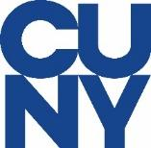

500 Grand Concourse, Bronx, NY 10451

FOLLOW US

Facebook: @HostosCC | Twitter: @HostosCollege | Instagram: @HostosCollege

