Setting up appointment availability
Please follow this guide carefully to correctly set up appointment availability. Important – you must use the correct service when setting your availability. See Section 4 for more information.
- Go to the Availabilities tab, Actions Add Time

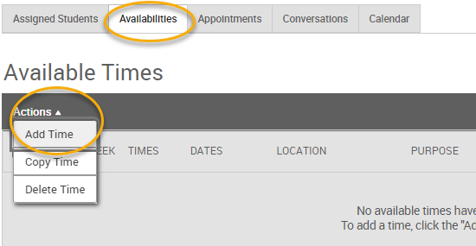

- Start adding your availability
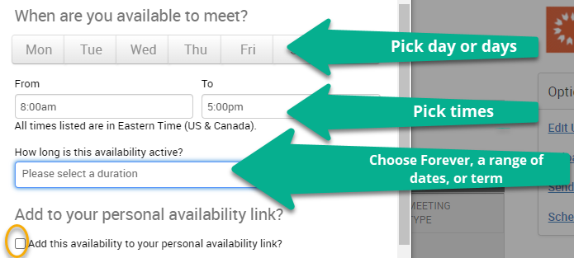
*Check “Add to personal link” if you’d like a shareable link you can send to students to book with you

- Select Availability type
Hostos is not currently using Appointment Campaigns for individual staff.
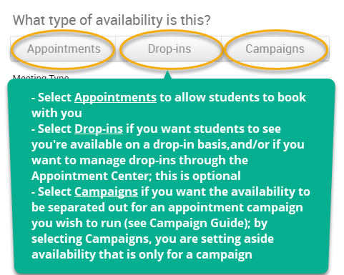

Next page…

- Enter additional details and save
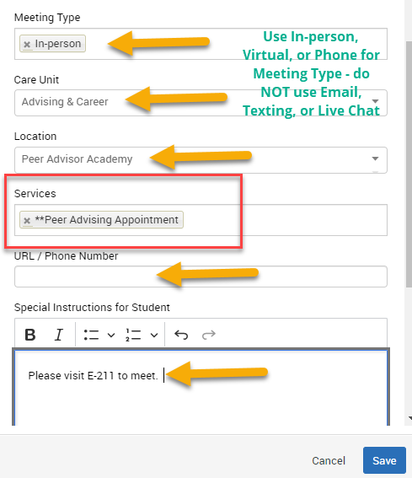

- Meeting type – you can list more than one type
  - Do NOT use Email, Texting, or Live Chat (SIC) for setting appointment availability
  - Use In-person, Virtual, or Phone
- Care Unit – the top-level organizational structure
- Location – your specific office/department
- Service – Make sure you only use Services that are approved by your department or program.
- Course – some Appointment services will ask you to enter the course or courses affiliated with the appointment. For instance, for Math Tutoring, you would then enter, for example, MAT119, MAT120, etc.
- URL – add Zoom link, if applicable

- You now have appointment availability!
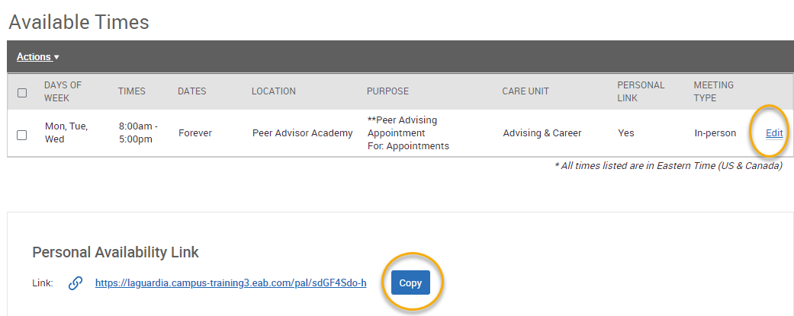
- You can edit the availability at any time
- You may need to create multiple availabilities to capture the nuance of your schedule. For instance, Mondays may be Virtual only, while Tuesdays and Thursdays are in-person only.
- As long as you have synced your Outlook calendar with your Navigate calender, students will not be able to book appointment during a busy block, even if you set up appointment availability for the same time.

- As students book appointments, you can see them in the Appointments tab
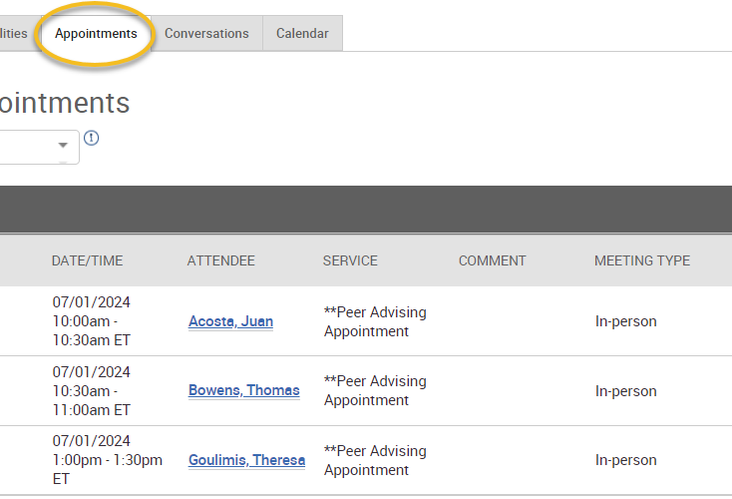

Tip: Use Actions Cancel to cancel appointments if needed (if sick, etc.)

