Faculty Quick Guide

Viewing students in your courses/looking up students
Log into Navigate, and then toggle from Staff Home to Professor Home
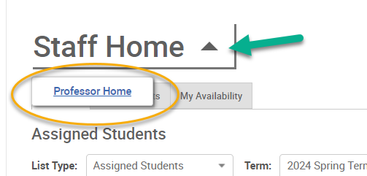
Note: Staff Home will show assigned students, which applies for Faculty Mentors, Program Directors, and Clinical Health Faculty Advisors

Scroll down to the Students In My Courses section to view students. You can select the Term dropdown to select prior or future terms. Click a name to see their profile, which includes academic history & more.
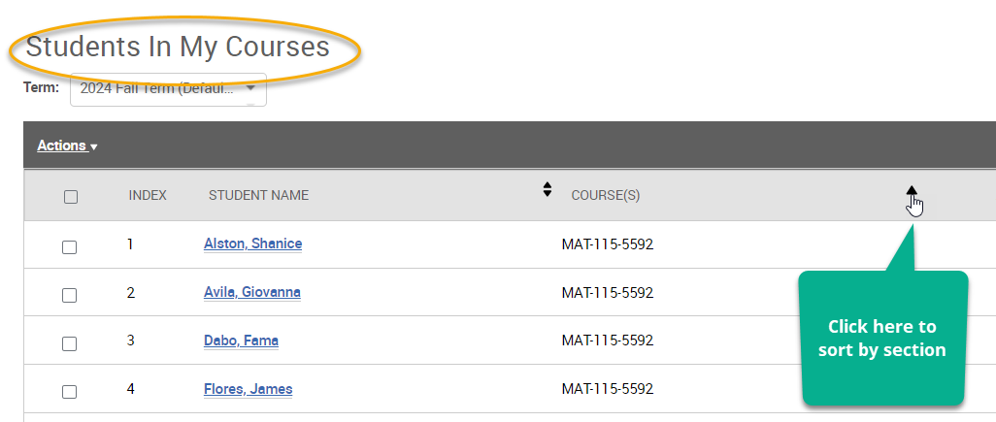

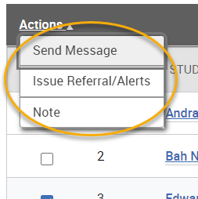
Use Actions to send messages, issue Alerts or Referrals, or to enter Notes

ALSO: Use the top Search Bar to search for any student. Once on the profile, use Options to send messages, enter notes, and more.
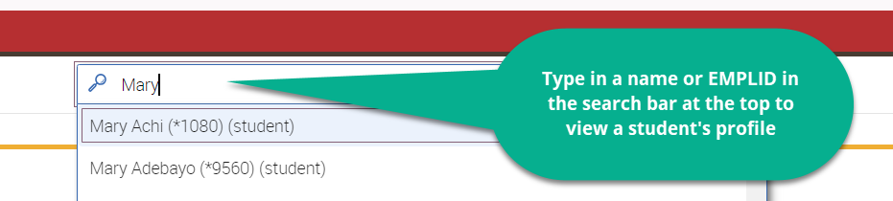

Student Profile
Use “History” to see advising notes and appointment history. Use Courses to see an academic transcript. Use Path to view the student’s in-take survey. Go to More -> Conversations to see messages sent to the student.
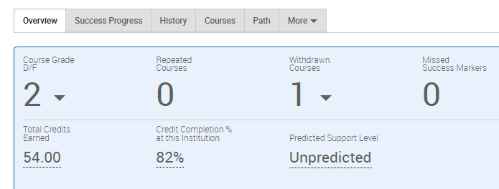

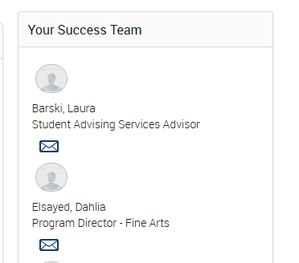
Scroll down to view the Success Team, which includes the assigned academic advisor.

Adapted with permission from La Guardia Community College

